3Operating system I

Assignment #3

**CPU Schedulers Simulator**

Write a java program to simulate the following schedulers:

1. **preemptive** Shortest- Job First (SJF) Scheduling with context switching
2. Round Robin (RR) with context switching
3. **preemptive** Priority Scheduling (Provide a solution to avoid starvation problem)
4. Multi level Scheduling :
   1. The schedule consists of 2 queues
   2. The first queue is Round Robin (Quantum will be input )
   3. The second queue is FCFS (preemptive)
   4. The first queue always has higher priority. So the second queue starts/resumes execution only if the first queue is empty
   5. The process input is name, arrival, burst and the queue number that it will enter (1 or 2)
   6. The process doesn’t change the queue that it enters

**Example :**

**Quantum time for the first queue (RR): 2**

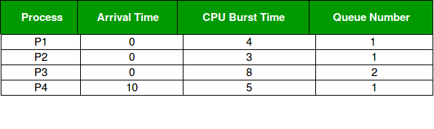

**Answer:**

At starting both queues have process so process in queue 1 (P1, P2) runs first (because of higher priority) in the round robin fashion and completes after 7 units then process in queue 2 (P3) starts running (as there is no process in queue 1) but while it is running P4 comes in queue 1 and interrupts P3 and start running for 5 second and after its completion P3 takes the CPU and completes its execution

**Program Input**

* Number of processes
* Name of each process
* Burst Time
* Arrival time
* Context switching (for question 1 and 2 only)
* Round robin Time Quantum (for question 2 and 4 only)
* Priority (for question 3 only)
* Queue number that the process will enter (for question 4 only)

**Program Output**

For each scheduler output the following:

* + Processes execution order
  + Waiting Time for each process
  + Turnaround Time for each process
  + Average Waiting Time
  + Average Turnaround Time
* The assignment is submitted in group of max. 4 students and min. 2 students.
* Late submission is not allowed

**Grading Criteria**

|  |  |  |  |  |  |
| --- | --- | --- | --- | --- | --- |
|  | preemptive Shortest- Job First (SJF) Scheduling | Round Robin (RR) Scheduling | Priority Scheduling | Multi level | Grade |
| Processes execution order | 5 | 5 | 5 | 5 | **20** |
| Waiting Time for each process | 2.5 | 5 | 2.5 | 5 | **15** |
| Turnaround Time for each process | 2.5 | 5 | 2.5 | 5 | **15** |
| Average Waiting Time | 2.5 | 2.5 | 2.5 | 2.5 | **10** |
| Average Turnaround Time | 2.5 | 2.5 | 2.5 | 2.5 | **10** |
| Grade | **15** | **20** | **15** | **20** | **70** |